Section 11B-607 Bathtubs
Diagram
UpCodes Diagram (1)
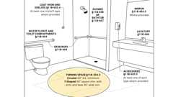Primary
Accessible Bathing Facilities (11B)
Building product (1)
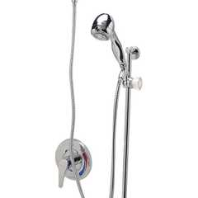
Temp-Gard® III Tub and Hand Wall Shower Unit w/ 24 Slide Bar 60 Metal Hose NPT Connections and Vacuum Breaker - Z7300-SS-MT-HW6
Zurn

11B-607.1 General
Bathtubs shall comply with Section 11B-607.
11B-607.2 Clearance
Clearance in front of bathtubs shall extend the length of the bathtub and shall be 48 inches (1219 mm) wide minimum for forward approach and 30 inches (762 mm) wide minimum for parallel approach. A lavatory complying with Section 11B-606 shall be permitted at the control end of the clearance. Where a permanent seat is provided at the head end of the bathtub, the clearance shall extend 12 inches (305 mm) minimum beyond the wall at the head end of the bathtub.
FIGURE 11B-607.2—CLEARANCE FOR BATHTUBS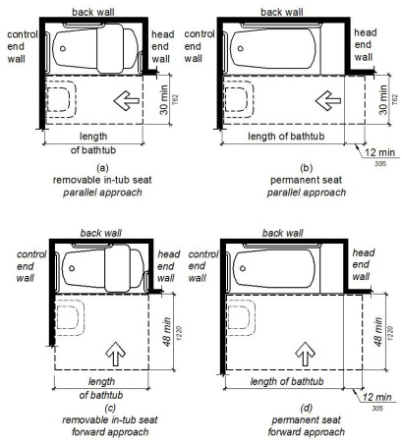
11B-607.3 Seat
A permanent seat at the head end of the bathtub or a removable in-tub seat shall be provided. Seats shall comply with Section 11B-610.
11B-607.4 Grab Bars
Grab bars for bathtubs shall comply with Section 11B-609 and shall be provided in accordance with Section 11B-607.4.1 or 11B-607.4.2. Where separate grab bars are required on adjacent walls at a common mounting height, an L-shaped or U-shaped grab bar meeting the dimensional requirements of Section 11B-607.4.1 or 11B-607.4.2 shall be permitted.
Exceptions:
- Reserved.
- In residential dwelling units, grab bars shall not be required to be installed in bathtubs located in bathing facilities provided that reinforcement has been installed in walls and located so as to permit the installation of grab bars complying with Section 11B-607.4.
11B-607.4.1 Bathtubs With Permanent Seats
For bathtubs with permanent seats, grab bars shall be provided in accordance with Section 11B-607.4.1.
FIGURE 11B-607.4.1—GRAB BARS FOR BATHTUBS WITH PERMANENT SEATS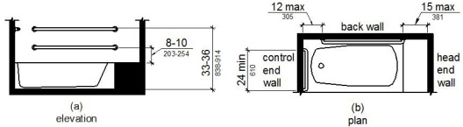
11B-607.4.1.1 Back Wall
Two grab bars shall be installed on the back wall, one located in accordance with Section 11B-609.4 and the other located 8 inches (203 mm) minimum and 10 inches (254 mm) maximum above the rim of the bathtub. Each grab bar shall be installed 15 inches (381 mm) maximum from the head end wall and 12 inches (305 mm) maximum from the control end wall.
11B-607.4.1.2 Control End Wall
A grab bar 24 inches (610 mm) long minimum shall be installed on the control end wall at the front edge of the bathtub.
11B-607.4.2 Bathtubs Without Permanent Seats
For bathtubs without permanent seats, grab bars shall comply with Section 11B-607.4.2.
FIGURE 11B-607.4.2—GRAB BARS FOR BATHTUBS WITH REMOVABLE IN-TUB SEATS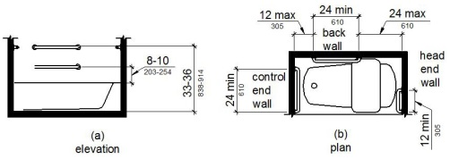
11B-607.4.2.1 Back Wall
Two grab bars shall be installed on the back wall, one located in accordance with Section 11B-609.4 and the other located 8 inches (203 mm) minimum and 10 inches (254 mm) maximum above the rim of the bathtub. Each grab bar shall be 24 inches (610 mm) long minimum and shall be installed 24 inches (610 mm) maximum from the head end wall and 12 inches (305 mm) maximum from the control end wall.
11B-607.4.2.2 Control End Wall
A grab bar 24 inches (610 mm) long minimum shall be installed on the control end wall at the front edge of the bathtub.
11B-607.4.2.3 Head End Wall
A grab bar 12 inches (305 mm) long minimum shall be installed on the head end wall at the front edge of the bathtub.
11B-607.5 Controls
Controls, other than drain stoppers, shall be located on an end wall. Controls shall be between the bathtub rim and grab bar, and between the open side of the bathtub and the centerline of the width of the bathtub. Controls shall comply with Section 11B-309.4.
FIGURE 11B-607.5—BATHTUB CONTROL LOCATION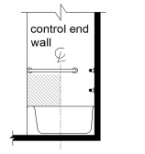
Building products (2)
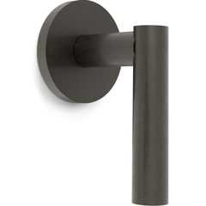
Loft Wall Mounted Trim
Watermark Designs

Temp-Gard® III Tub and Hand Wall Shower Unit w/ 24 Slide Bar 60 Metal Hose NPT Connections and Vacuum Breaker - Z7300-SS-MT-HW6
Zurn

11B-607.6 Shower Spray Unit and Water
A shower spray unit with a hose 59 inches (1499 mm) long minimum that can be used both as a fixed-position shower head and as a hand-held shower shall be provided. The shower spray unit shall have an on/off control with a non-positive shut-off. If an adjustable-height shower head on a vertical bar is used, the bar shall be installed so as not to obstruct the use of grab bars. Bathtub shower spray units shall deliver water that is 120°F (49°C) maximum.
Building product (1)
Temp-Gard® III Tub and Hand Wall Shower Unit w/ 24 Slide Bar 60 Metal Hose NPT Connections and Vacuum Breaker - Z7300-SS-MT-HW6
Zurn

11B-607.7 Bathtub Enclosures
Enclosures for bathtubs shall not obstruct controls, faucets, shower and spray units or obstruct transfer from wheelchairs onto bathtub seats or into bathtubs. Enclosures on bathtubs shall not have tracks installed on the rim of the open face of the bathtub.
Section 11B-608 Shower Compartments
Diagram
UpCodes Diagram (1)
Primary
Accessible Bathing Facilities (11B)
Building product (1)
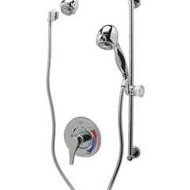
Temp-Gard® III Shower Unit - Z7300-SS-HW2-MT
Zurn

11B-608.1 General
Shower compartments shall comply with Section 11B-608.
11B-608.2 Size and Clearances for Shower Compartments
Shower compartments shall have sizes and clearances complying with Section 11B-608.2.
11B-608.2.1 Transfer Type Shower Compartments
Transfer type shower compartments shall be 36 inches (914 mm) by 36 inches (914 mm) clear inside dimensions measured at the center points of opposing sides and shall have a 36-inch (914 mm) wide minimum entry on the face of the shower compartment. Clearance of 36 inches (914 mm) wide minimum by 48 inches (1219 mm) long minimum measured from the control wall shall be provided. Transfer type shower compartments shall be permitted in transient lodging guest rooms, multibedroom housing units in undergraduate student housing and residential dwelling units; and shall not be permitted at other locations to meet the requirements of Section 11B-213.3.6.
FIGURE 11B-608.2.1—
TRANSFER TYPE SHOWER COMPARTMENT SIZE AND CLEARANCE
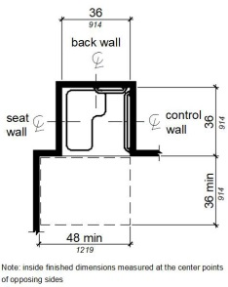
11B-608.2.2 Standard Roll-in Type Shower Compartments
Standard roll-in type shower compartments shall be 30 inches (762 mm) wide minimum by 60 inches (1524 mm) deep minimum clear inside dimensions measured at center points of opposing sides with a full opening width on the long side.
FIGURE 11B-608.2.2—
STANDARD ROLL-IN TYPE SHOWER COMPARTMENT SIZE AND CLEARANCE
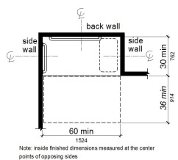
11B-608.2.2.1 Clearance
A 36 inch (914 mm) wide minimum by 60 inch (1524 mm) long minimum clearance shall be provided adjacent to the open face of the shower compartment.
Exception: Reserved.
11B-608.2.3 Alternate Roll-in Type Shower Compartments
Alternate roll-in type shower compartments shall be 36 inches (914 mm) wide and 60 inches (1524 mm) deep minimum clear inside dimensions measured at center points of opposing sides. A 36 inch (914 mm) wide minimum entry shall be provided at one end of the long side of the compartment.
FIGURE 11B-608.2.3—
ALTERNATE ROLL-IN TYPE SHOWER COMPARTMENT SIZE AND CLEARANCE
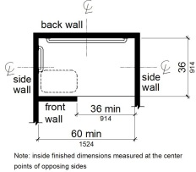
11B-608.3 Grab Bars
Grab bars shall comply with Section 11B-609 and shall be provided in accordance with Section 11B-608.3. Where multiple grab bars are used, required horizontal grab bars shall be installed at the same height above the finish floor. Where separate grab bars are required on adjacent walls at a common mounting height, an L-shaped or U-shaped grab bar meeting the dimensional requirements of Section 11B-608.3.2 or 11B-608.3.3 shall be permitted.
Exceptions:
- Reserved.
- In residential dwelling units, grab bars shall not be required to be installed in showers located in bathing facilities provided that reinforcement has been installed in walls and located so as to permit the installation of grab bars complying with Section 11B-608.3.
11B-608.3.1 Transfer Type Shower Compartments
In transfer type compartments, grab bars shall be provided across the control wall and back wall to a point 18 inches (457 mm) from the control wall.
FIGURE 11B-608.3.1—
GRAB BARS FOR TRANSFER TYPE SHOWERS
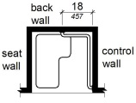
11B-608.3.2 Standard Roll-in Type Shower Compartments
Grab bars shall be provided on the back wall and the side wall opposite the seat. Grab bars shall not be provided above the seat. Grab bars shall be installed 6 inches (152 mm) maximum from adjacent walls.
FIGURE 11B-608.3.2—
GRAB BARS FOR STANDARD ROLL-IN TYPE SHOWER
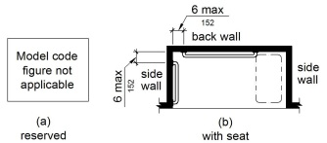
11B-608.3.3 Alternate Roll-in Type Shower Compartments
In alternate roll-in type shower compartments, grab bars shall be provided on the back wall and the side wall farthest from the compartment entry. Grab bars shall not be provided above the seat. Grab bars shall be installed 6 inches (152 mm) maximum from adjacent walls.
FIGURE 11B-608.3.3—
GRAB BARS FOR ALTERNATE ROLL-IN TYPE SHOWERS
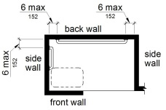
11B-608.4 Seats
A folding seat shall be provided in roll-in type showers and transfer type shower compartments. Seats shall comply with Section 11B-610.
Exception: In residential dwelling units, seats shall not be required in shower compartments provided that reinforcement has been installed in walls so as to permit the installation of seats complying with Section 11B-608.4.
11B-608.5 Controls
Controls, faucets and shower spray units shall comply with Section 11B-309.4. Controls and faucets shall allow the user to close and open the water supply.
Building product (1)
Temp-Gard® III Shower Unit - Z7300-SS-HW2-MT
Zurn

11B-608.5.1 Transfer Type Shower Compartments
In transfer type shower compartments, the controls, faucets and shower spray unit shall be installed on the side wall opposite the seat 38 inches (965 mm) minimum and 48 inches (1219 mm) maximum above the shower floor and shall be located on the control wall 15 inches (380 mm) maximum from the centerline of the seat toward the shower opening.
FIGURE 11B-608.5.1—
TRANSFER TYPE SHOWER COMPARTMENT CONTROL LOCATION
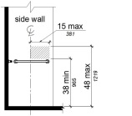
11B-608.5.2 Standard Roll-in Type Shower Compartments
In standard roll-in type shower compartments, the controls, faucets and the shower spray unit shall be located on the back wall of the compartment adjacent to the seat wall 16 inches (406 mm) minimum and 27 inches (686 mm) maximum from the seat wall; and shall be located above the grab bar, but no higher than 48 inches (1219 mm) above the shower floor.
FIGURE 11B-608.5.2—
STANDARD ROLL-IN TYPE SHOWER COMPARTMENT CONTROL LOCATION
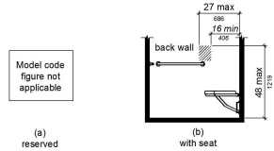
11B-608.5.3 Alternate Roll-in Type Shower Compartments
In alternate roll-in type shower compartments, the controls, faucets and shower spray unit shall be located on the side wall of the compartment adjacent to the seat wall 16 inches (406 mm) minimum and 27 inches (686 mm) maximum from the seat wall or shall be located on the back wall opposite the seat 15 inches (381 mm) maximum, left or right of the centerline of the seat. The controls, faucets and shower spray units shall be located above the grab bar, but no higher than 48 inches (1219 mm) above the shower floor.
FIGURE 11B-608.5.3—
ALTERNATE ROLL-IN TYPE SHOWER COMPARTMENT CONTROL LOCATION
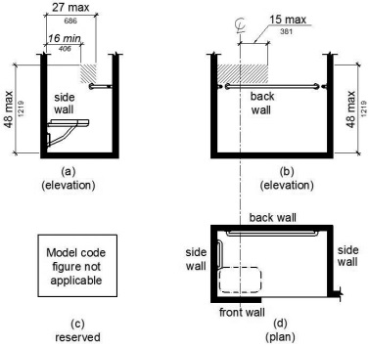
11B-608.6 Shower Spray Unit and Water
A shower spray unit with a hose 59 inches (1499 mm) long minimum that can be used both as a fixed-position shower head and as a hand-held shower shall be provided. The shower spray unit shall have an on/off control with a non-positive shut-off. If an adjustable-height shower head on a vertical bar is used, the bar shall be installed so as not to obstruct the use of grab bars. Shower spray units shall deliver water that is 120°F (49°C) maximum.
Exception: Where subject to excessive vandalism, two fixed shower heads shall be permitted instead of a hand-held spray unit in facilities that are not medical care facilities, long-term care facilities, transient lodging guest rooms or residential dwelling units. Each shower head shall be installed so it can be operated independently of the other and shall have swivel angle adjustments, both vertically and horizontally. One shower head shall be located at a height of 48 inches (1219 mm) maximum above the shower finish floor.
Building product (1)
Temp-Gard® III Shower Unit - Z7300-SS-HW2-MT
Zurn

11B-608.7 Thresholds
Thresholds in roll-in type shower compartments shall be ¹/₂ inch (12.7 mm) high maximum in accordance with Section 11B-303. In transfer type shower compartments, thresholds ¹/₂ inch (12.7 mm) high maximum shall be beveled, rounded or vertical.
Exception: A threshold 2 inches (51 mm) high maximum shall be permitted in transfer type shower compartments in existing facilities where provision of a ¹/₂ inch (12.7 mm) high threshold would disturb the structural reinforcement of the floor slab.
11B-608.8 Shower Enclosures
Enclosures for shower compartments shall not obstruct controls, faucets and shower spray units or obstruct transfer from wheelchairs onto shower seats.
11B-608.9 Shower Floor or Ground Surface
Floor or ground surfaces of showers shall comply with Section 11B-302.1 and shall be sloped 1:48 maximum in any direction. Where drains are provided, grate openings shall be ¹/₄ inch (6.4 mm) maximum and flush with the floor surface.
11B-608.10 Soap Dish
Where a soap dish is provided, it shall be located on the control wall at 40 inches (1016 mm) maximum above the shower floor, and within the reach limits from the seat.
Section 11B-609 Grab Bars
Diagram
UpCodes Diagrams (4)
Primary
Accessible Bathing Facilities (11B)
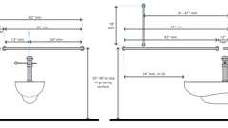
Water Closet Grab Bars
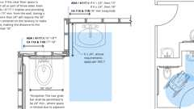
Grab Bar - Recessed Lavatory
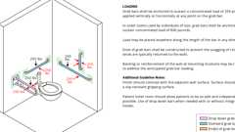
Grab Bar: Structural Strength
11B-609.1 General
Grab bars in toilet facilities and bathing facilities shall comply with Section 11B-609.
11B-609.2 Cross Section
Grab bars shall have a cross section complying with Section 11B-609.2.1 or 11B-609.2.2.
11B-609.2.1 Circular Cross Section
Grab bars with circular cross sections shall have an outside diameter of 1¹/₄ inches (32 mm) minimum and 2 inches (51 mm) maximum.
11B-609.2.2 Non-Circular Cross Section
Grab bars with non-circular cross sections shall have a cross-section dimension of 2 inches (51 mm) maximum and a perimeter dimension of 4 inches (102 mm) minimum and 4.8 inches (122 mm) maximum.
FIGURE 11B-609.2.2—
GRAB BAR NON-CIRCULAR CROSS SECTION
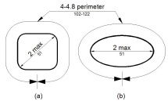
11B-609.3 Spacing
The space between the wall and the grab bar shall be 1¹/₂ inches (38 mm). The space between the grab bar and projecting objects below and at the ends shall be 1¹/₂ inches (38 mm) minimum. The space between the grab bar and projecting objects above shall be 12 inches (305 mm) minimum.
Exceptions:
- The space between the grab bars and shower controls, shower fittings, and other grab bars above shall be permitted to be 1¹/₂ inches (38 mm) minimum.
- For L-shaped or U-shaped grab bars complying with Section 11B-609.9 the space between the walls and the grab bar shall be 1¹/₂ inches (38 mm) minimum for a distance of 6 inches on either side of the inside corner between two adjacent wall surfaces.
FIGURE 11B-609.3—
SPACING OF GRAB BARS
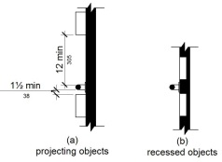
11B-609.4 Position of Grab Bars
Grab bars shall be installed in a horizontal position, 33 inches (838 mm) minimum and 36 inches (914 mm) maximum above the finish floor measured to the top of the gripping surface, except that at water closets for children's use complying with Section 11B-604.9, grab bars shall be installed in a horizontal position 18 inches (457 mm) minimum and 27 inches (686 mm) maximum above the finish floor measured to the top of the gripping surface. The height of the lower grab bar on the back wall of a bathtub shall comply with Section 11B-607.4.1.1 or 11B-607.4.2.1.
11B-609.5 Surface Hazards
Grab bars and any wall or other surfaces adjacent to grab bars shall be free of sharp or abrasive elements and shall have rounded edges.
11B-609.6 Fittings
Grab bars shall not rotate within their fittings.
11B-609.7 Installation
Grab bars shall be installed in any manner that provides a gripping surface at the specified locations and that does not obstruct the required clear floor space.
11B-609.8 Structural Strength
Diagram
Allowable stresses shall not be exceeded for materials used when a vertical or horizontal force of 250 pounds (1112 N) is applied at any point on the grab bar, fastener, mounting device or supporting structure.
UpCodes Diagram (1)
Grab Bar: Structural Strength
11B-609.9 Alternate Configuration
L-shaped or U-shaped grab bars shall be permitted.
Section 11B-610 Seats
11B-610.1 General
Seats in bathtubs and shower compartments shall comply with Section 11B-610.
11B-610.2 Bathtub Seats
The top of bathtub seats shall be 17 inches (432 mm) minimum and 19 inches (483 mm) maximum above the bathroom finish floor. The depth of a removable in-tub seat shall be 15 inches (381 mm) minimum and 16 inches (406 mm) maximum. The seat shall be capable of secure placement. Permanent seats at the head end of the bathtub shall be 15 inches (381 mm) deep minimum and shall extend from the back wall to or beyond the outer edge of the bathtub.
FIGURE 11B-610.2—
BATHTUB SEATS
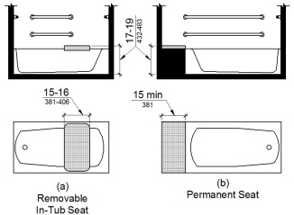
11B-610.3 Shower Compartment Seats
A seat in a standard roll-in shower compartment shall be a folding type, shall be installed on the side wall adjacent to the controls, and shall extend from the back wall to a point within 3 inches (76 mm) of the compartment entry. A seat in an alternate roll-in type shower compartment shall be a folding type, shall be installed on the front wall opposite the back wall, and shall extend from the adjacent side wall to a point within 3 inches (76 mm) of the compartment entry. In transfer type showers, the seat shall extend from the back wall to a point within 3 inches (76 mm) of the compartment entry. The top of the seat shall be 17 inches (432 mm) minimum and 19 inches (483 mm) maximum above the bathroom finish floor. When folded, the seat shall extend 6 inches (152 mm) maximum from the mounting wall. Seats shall comply with Section 11B-610.3.1 or 11B-610.3.2.
FIGURE 11B-610.3—
EXTENT OF SEAT
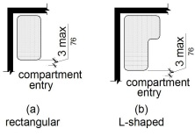
11B-610.3.1 Rectangular Seats
The rear edge of a rectangular seat shall be 2¹/₂ inches (64 mm) maximum and the front edge 15 inches (381 mm) minimum and 16 inches (406 mm) maximum from the seat wall. The side edge of the seat shall be 1¹/₂ inches (38 mm) maximum from the adjacent wall.
FIGURE 11B-610.3.1—
RECTANGULAR SHOWER SEAT
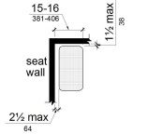
11B-610.3.2 L-Shaped Seats
The rear edge of an L-shaped seat shall be 2¹/₂ inches (64 mm) maximum and the front edge 15 inches (381 mm) minimum and 16 inches (406 mm) maximum from the seat wall. The rear edge of the "L" portion of the seat shall be 1¹/₂ inches (38 mm) maximum from the wall and the front edge shall be 14 inches (356 mm) minimum and 15 inches (381 mm) maximum from the wall. The end of the "L" shall be 22 inches (559 mm) minimum and 23 inches (584 mm) maximum from the main seat wall.
FIGURE 11B-610.3.2—
L-SHAPED SHOWER SEAT
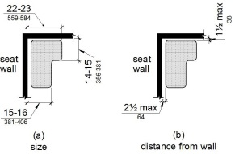
11B-610.4 Structural Strength
Allowable stresses shall not be exceeded for materials used when a vertical or horizontal force of 250 pounds (1112 N) is applied at any point on the seat, fastener, mounting device or supporting structure.
Section 11B-611 Washing Machines and Clothes Dryers
11B-611.1 General
Diagram
Washing machines and clothes dryers shall comply with Section 11B-611.
UpCodes Diagram (1)
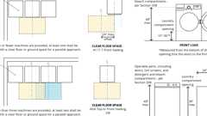
Accessibility at Washers & Clothes Dryers
11B-611.2 Clear Floor Space
A clear floor or ground space complying with Section 11B-305 positioned for parallel approach shall be provided. The clear floor or ground space shall be centered on the appliance.
11B-611.3 Operable Parts
Operable parts, including doors, lint screens and detergent and bleach compartments shall comply with Section 11B-309.
11B-611.4 Height
Top loading machines shall have the door to the laundry compartment located 36 inches (914 mm) maximum above the finish floor. Front loading machines shall have the bottom of the opening to the laundry compartment located 15 inches (381 mm) minimum and 36 inches (914 mm) maximum above the finish floor.
FIGURE 11B-611.4—
HEIGHT OF LAUNDRY COMPARTMENT OPENING
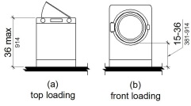
Section 11B-612 Saunas and Steam Rooms
11B-612.1 General
Saunas and steam rooms shall comply with Section 11B-612.
11B-612.2 Bench
Diagram
Where seating is provided in saunas and steam rooms, at least one bench shall comply with Section 11B-903. Doors shall not swing into the clear floor space required by Section 11B-903.2.
Exception: A readily removable bench shall be permitted to obstruct the turning space required by Section 11B-612.3 and the clear floor or ground space required by Section 11B-903.2.
UpCodes Diagram (1)
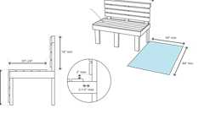
Benches (CA 11B)
11B-612.3 Turning Space
A turning space complying with Section 11B-304 shall be provided within saunas and steam rooms.
Division 7 Communication Elements and Features
Section 11B-701 General
11B-701.1 Scope
The provisions of Division 7 shall apply where required by Division 2 or where referenced by a requirement in this chapter .
Section 11B-702 Fire Alarm Systems
11B-702.1 General
Fire alarm systems shall have permanently installed audible and visible alarms complying with NFPA 72 and Chapter 9, Sections 907.5.2.1 and 907.5.2.3.
Exception: Reserved.
Section 11B-703 Signs
11B-703.1 General
Diagram
Signs shall comply with Section 11B-703. Where both visual and tactile characters are required, either one sign with both visual and tactile characters or two separate signs, one with visual, and one with tactile characters, shall be provided.
UpCodes Diagrams (3)
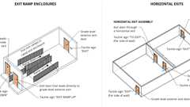
Exit Door Signs: Ramps / Horiz. Exits
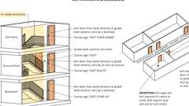
Exit Door Signs at Stairways and Corridors
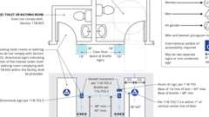
Signs: Toilet / Bathing Rooms (CA 11B)
11B-703.1.1 Plan Review and Inspection
Signs as specified in Section 11B-703, or in other sections of this code, when included in the construction of new buildings or facilities, or when included, altered or replaced due to additions, alterations or renovations to existing buildings or facilities, and when a permit is required, shall comply with Sections 11B-703.1.1.1 and 11B-703.1.1.2.
11B-703.1.1.1 Plan Review
Plans, specifications or other information indicating compliance with these regulations shall be submitted to the enforcing agency for review and approval.
11B-703.1.1.2 Inspection
Signs and identification devices shall be field inspected after installation and approved by the enforcing agency prior to the issuance of a final certificate of occupancy per Chapter 1, Division II, Section 111, or final approval where no certificate of occupancy is issued. The inspection shall include, but not be limited to, verification that Braille dots and cells are properly spaced and the size, proportion and type of raised characters are in compliance with these regulations.
11B-703.2 Raised Characters
Raised characters shall comply with Section 11B-703.2 and shall be duplicated in Braille complying with Section 11B-703.3. Raised characters shall be installed in accordance with Section 11B-703.4.
11B-703.2.1 Depth
Raised characters shall be ¹/₃₂ inch (0.8 mm) minimum above their background.
11B-703.2.2 Case
Characters shall be uppercase.
11B-703.2.3 Style
Characters shall be sans serif. Characters shall not be italic, oblique, script, highly decorative or of other unusual forms.
11B-703.2.4 Character Proportions
Characters shall be selected from fonts where the width of the uppercase letter "O" is 60 percent minimum and 110 percent maximum of the height of the uppercase letter "I".
11B-703.2.5 Character Height
Diagram
Character height measured vertically from the baseline of the character shall be ⁵/₈ inch (15.9 mm) minimum and 2 inches (51 mm) maximum based on the height of the uppercase letter "I".
Exception: Reserved.
FIGURE 11B-703.2.5—
HEIGHT OF RAISED CHARACTERS
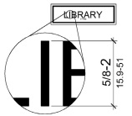
UpCodes Diagram (1)
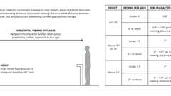
Sign Character Height: Viewing Dist.
11B-703.2.6 Stroke Thickness
Stroke thickness of the uppercase letter "I" shall be 15 percent maximum of the height of the character.
11B-703.2.7 Character Spacing
Character spacing shall be measured between the two closest points of adjacent raised characters within a message, excluding word spaces. Where characters have rectangular cross sections, spacing between individual raised characters shall be ¹/₈ inch (3.2 mm) minimum and 4 times the raised character stroke width maximum. Where characters have other cross sections, spacing between individual raised characters shall be ¹/₁₆ inch (1.6 mm) minimum and 4 times the raised character stroke width maximum at the base of the cross sections, and ¹/₈ inch (3.2 mm) minimum and 4 times the raised character stroke width maximum at the top of the cross sections. Characters shall be separated from raised borders and decorative elements ³/₈ inch (9.5 mm) minimum.
11B-703.2.8 Line Spacing
Spacing between the baselines of separate lines of raised characters within a message shall be 135 percent minimum and 170 percent maximum of the raised character height.
11B-703.2.9 Format
Text shall be in a horizontal format.
11B-703.3 Braille
Braille shall be contracted (Grade 2) and shall comply with Sections 11B-703.3 and 11B-703.4.
11B-703.3.1 Dimensions and Capitalization
Braille dots shall have a domed or rounded shape and shall comply with Table 11B-703.3.1. The indication of an uppercase letter or letters shall only be used before the first word of sentences, proper nouns and names, individual letters of the alphabet, initials and acronyms.
TABLE 11B-703.3.1—
BRAILLE DIMENSIONS
MEASUREMENT RANGE | MINIMUM IN INCHES  MAXIMUM IN INCHES
Dot base diameter | 0.059 (1.5 mm) to 0.063 (1.6 mm)
Distance between two dots in the same cell¹ | 0.100 (2.5 mm)
Distance between corresponding dots in adjacent cells¹ | 0.300 (7.6 mm)
Dot height | 0.025 (0.6 mm) to 0.037 (0.9 mm)
Distance between corresponding dots from one cell directly below¹ | 0.395 (10 mm) to 0.400 (10.2 mm)
1. Measured center to center.
FIGURE 11B-703.3.1—
BRAILLE MEASUREMENT
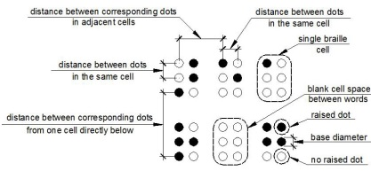
11B-703.3.2 Position
Braille shall be positioned below the corresponding text in a horizontal format, flush left or centered. If text is multilined, Braille shall be placed below the entire text. Braille shall be separated ³/₈ inch (9.5 mm) minimum and ¹/₂ inch (12.7 mm) maximum from any other tactile characters and ³/₈ inch (9.5 mm) minimum from raised borders and decorative elements.
Exception: Braille provided on elevator car controls shall be separated ³/₁₆ inch (4.8 mm) minimum and shall be located directly below the corresponding raised characters or symbols.
FIGURE 11B-703.3.2—
POSITION OF BRAILLE
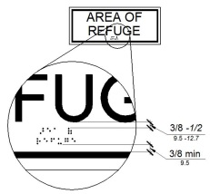
11B-703.4 Installation Height and Location
Signs with tactile characters shall comply with Section 11B-703.4.
11B-703.4.1 Height Above Finish Floor or Ground
Diagram
Tactile characters on signs shall be located 48 inches (1219 mm) minimum above the finish floor or ground surface, measured from the baseline of the lowest Braille cells and 60 inches (1524 mm) maximum above the finish floor or ground surface, measured from the baseline of the highest line of raised characters.
Exception: Tactile characters for elevator car controls shall not be required to comply with Section 11B-703.4.1.
FIGURE 11B-703.4.1—
HEIGHT OF TACTILE CHARACTERS ABOVE FINISH FLOOR OR GROUND
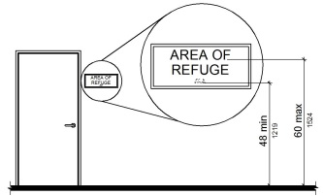
UpCodes Diagram (1)
Sign Character Height: Viewing Dist.
11B-703.4.2 Location
Where a tactile sign is provided at a door, the sign shall be located alongside the door at the latch side. Where a tactile sign is provided at double doors with one active leaf, the sign shall be located on the inactive leaf. Where a tactile sign is provided at double doors with two active leafs, the sign shall be located to the right of the right hand door. Where there is no wall space at the latch side of a single door or at the right side of double doors, signs shall be located on the nearest adjacent wall. Signs containing tactile characters shall be located so that a clear floor space of 18 inches (457 mm) minimum by 18 inches (457 mm) minimum, centered on the tactile characters, is provided beyond the arc of any door swing between the closed position and 45 degree open position. Where provided, signs identifying permanent rooms and spaces shall be located at the entrance to, and outside of the room or space. Where provided, signs identifying exits shall be located at the exit door when approached in the direction of egress travel.
Exception: In alterations where sign installation locations identified in Section 11B-703.4.2 are obstructed or otherwise unavailable for sign installation, signs with tactile characters shall be permitted on the push side of doors with closers and without hold-open devices.
FIGURE 11B-703.4.2—
LOCATION OF TACTILE SIGNS AT DOORS
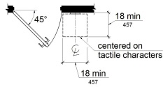
11B-703.5 Visual Characters
Diagram
Visual characters shall comply with Section 11B-703.5.
Exception: Where visual characters comply with Section 11B-703.2 and are accompanied by Braille complying with Section 11B-703.3, they shall not be required to comply with Sections 11B-703.5.2 through 11B-703.5.6, 11B-703.5.8 and 11B-703.5.9.
UpCodes Diagram (1)
Signs: Toilet / Bathing Rooms (CA 11B)
11B-703.5.1 Finish and Contrast
Characters and their background shall have a non-glare finish. Characters shall contrast with their background with either light characters on a dark background or dark characters on a light background.
11B-703.5.2 Case
Characters shall be uppercase or lowercase or a combination of both.
11B-703.5.3 Style
Characters shall be conventional in form. Characters shall not be italic, oblique, script, highly decorative or of other unusual forms.
11B-703.5.4 Character Proportions
Characters shall be selected from fonts where the width of the uppercase letter "O" is 60 percent minimum and 110 percent maximum of the height of the uppercase letter "I".
11B-703.5.5 Character Height
Diagram
Minimum character height shall comply with Table 11B-703.5.5. Viewing distance shall be measured as the horizontal distance between the character and an obstruction preventing further approach towards the sign. Character height shall be based on the uppercase letter "I".
Exception: Where provided, floor plans providing emergency procedures information in accordance with Title 19 shall not be required to comply with Section 11B-703.5.5.
TABLE 11B-703.5.5—
VISUAL CHARACTER HEIGHT
HEIGHT TO FINISH FLOOR OR  GROUND FROM BASELINE OF  CHARACTER | HORIZONTAL VIEWING DISTANCE | MINIMUM CHARACTER HEIGHT
40 inches (1016 mm) to less than or equal to 70 inches (1778 mm) | less than 72 inches (1829 mm) | ⁵/₈ inch (15.9 mm)
 | 72 inches (1829 mm) and greater | ⁵/₈ inch (15.9 mm), plus ¹/₈ inch (3.2 mm) per foot (305 mm) of viewing distance above 72 inches (1829 mm)
Greater than 70 inches (1778 mm) to less than or equal to 120 inches (3048 mm) | less than 180 inches (4572 mm) | 2 inches (51 mm)
 | 180 inches (4572 mm) and greater | 2 inches (51 mm), plus ¹/₈ inch (3.2 mm) per foot (305 mm) of viewing distance above 180 inches (4572 mm)
greater than 120 inches (3048 mm) | less than 21 feet (6401 mm) | 3 inches (76 mm)
greater than 120 inches (3048 mm) | 21 feet (6401 mm) and greater | 3 inches (76 mm), plus ¹/₈ inch (3.2 mm) per foot (305 mm) of viewing distance above 21 feet (6401 mm)
UpCodes Diagram (1)
Sign Character Height: Viewing Dist.
11B-703.5.6 Height From Finish Floor or Ground
Visual characters shall be 40 inches (1016 mm) minimum above the finish floor or ground.
Exceptions:
- Visual characters indicating elevator car controls shall not be required to comply with Section 11B-703.5.6.
- Floor-level exit signs complying with Chapter 10, Section 1013.7 shall not be required to comply with Section 11B-703.5.6.
- Where provided, floor plans providing emergency procedures information in accordance with Title 19 shall not be required to comply with Section 11B-703.5.6.
11B-703.5.7 Stroke Thickness
Stroke thickness of the uppercase letter "I" shall be 10 percent minimum and 20 percent maximum of the height of the character.
11B-703.5.8 Character Spacing
Character spacing shall be measured between the two closest points of adjacent characters, excluding word spaces. Spacing between individual characters shall be 10 percent minimum and 35 percent maximum of character height.
11B-703.5.9 Line Spacing
Spacing between the baselines of separate lines of characters within a message shall be 135 percent minimum and 170 percent maximum of the character height.
11B-703.5.10 Format
Text shall be in a horizontal format.
11B-703.6 Pictograms
Pictograms shall comply with Section 11B-703.6.
11B-703.6.1 Pictogram Field
Pictograms shall have a field height of 6 inches (152 mm) minimum. Characters and Braille shall not be located in the pictogram field.
FIGURE 11B-703.6.1—
PICTOGRAM FIELD
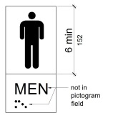
11B-703.6.2 Finish and Contrast
Pictograms and their field shall have a non-glare finish. Pictograms shall contrast with their field with either a light pictogram on a dark field or a dark pictogram on a light field.
11B-703.6.3 Text Descriptors
Pictograms shall have text descriptors located directly below the pictogram field. Text descriptors shall comply with Sections 11B-703.2, 11B-703.3 and 11B-703.4.
11B-703.7 Symbols of Accessibility
Symbols of accessibility shall comply with Section 11B-703.7.
11B-703.7.1 Finish and Contrast
Symbols of accessibility and their background shall have a non-glare finish. Symbols of accessibility shall contrast with their background with either a light symbol on a dark background or a dark symbol on a light background.
11B-703.7.2 Symbols
11B-703.7.2.1 International Symbol of Accessibility
Diagram
The International Symbol of Accessibility shall comply with Figure 11B-703.7.2.1. The symbol shall consist of a white figure on a blue background. The color blue shall approximate FS 15090 in Federal Standard 595C. A border may be provided inside or outside of the minimum required International Symbol of Accessibility dimension.
Exceptions:
- The appropriate enforcement agency may approve other colors provided the symbol contrast is light on dark or dark on light.
- On the accessibility function button on hall call consoles in a destination-oriented elevator system the International Symbol of Accessibility shall be a white symbol on a black background.
FIGURE 11B-703.7.2.1—
INTERNATIONAL SYMBOL OF ACCESSIBILITY
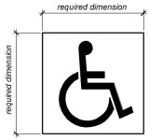
UpCodes Diagram (1)
Signs: Toilet / Bathing Rooms (CA 11B)
11B-703.7.2.2 International Symbol of TTY
The International Symbol of TTY shall comply with Figure 11B-703.7.2.2.
FIGURE 11B-703.7.2.2—
INTERNATIONAL SYMBOL OF TTY

11B-703.7.2.3 Volume Control Telephones
Telephones with a volume control shall be identified by a pictogram of a telephone handset with radiating sound waves on a square field such as shown in Figure 11B-703.7.2.3.
FIGURE 11B-703.7.2.3—
VOLUME CONTROL TELEPHONE
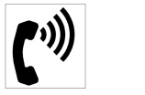
11B-703.7.2.4 Assistive Listening Systems
Assistive listening systems shall be identified by the International Symbol of Access for Hearing Loss complying with Figure 11B-703.7.2.4.
FIGURE 11B-703.7.2.4—
INTERNATIONAL SYMBOL OF ACCESS FOR HEARING LOSS

11B-703.7.2.5 Reserved
11B-703.7.2.6 Toilet and Bathing Facilities Geometric Symbols
Diagram
Geometric symbols at entrances to toilet and bathing rooms shall be mounted at 58 inches (1473 mm) minimum and 60 inches (1524 mm) maximum above the finish floor or ground surface measured from the centerline of the symbol. Where a door is provided the symbol shall be mounted within 1 inch (25 mm) of the vertical centerline of the door.
UpCodes Diagram (1)
Signs: Toilet / Bathing Rooms (CA 11B)
11B-703.7.2.6.1 Men's Toilet and Bathing Facilities
A triangle symbol shall be located at entrances to men's toilet and bathing facilities. The triangle symbol shall be an equilateral triangle ¹/₄ inch (6.4 mm) thick with edges 12 inches (305 mm) long and a vertex pointing upward. The color of the triangle symbol shall contrast with the color of the door or surface on which the triangle symbol is mounted, either light on a dark background or dark on a light background.
Exception: Within secure perimeter of detention and correctional facilities, geometric symbols shall not be required to be ¹/₄ inch (6.4 mm) thick.
11B-703.7.2.6.2 Women's Toilet and Bathing Facilities
A circle symbol shall be located at entrances to women's toilet and bathing facilities. The circle symbol shall be ¹/₄ inch (6.4 mm) thick and 12 inches (305 mm) in diameter. The color of the circle symbol shall contrast with the color of the door or surface on which the circle symbol is mounted, either light on a dark background or dark on a light background.
Exception: Within secure perimeter of detention and correctional facilities, geometric symbols shall not be required to be ¹/₄ inch (6.4 mm) thick.
11B-703.7.2.6.3 Unisex Toilet and Bathing Facilities
A combined circle and triangle symbol shall be located at entrances to unisex toilet and bathing facilities. The combined circle and triangle symbol shall consist of a circle symbol ¹/₄ inch (6.4 mm) thick and 12 inches (305 mm) in diameter with a ¹/₄ inch (6.4 mm) thick equilateral triangle symbol superimposed on and geometrically inscribed within the 12-inch (305 mm) diameter of the circle symbol. The vertices of the triangle symbol shall be located ¹/ ₄ inch (6.4 mm) maximum from the edge of the circle symbol with a vertex pointing upward. The color of the triangle symbol shall contrast with the color of the circle symbol, either light on a dark background or dark on a light background. The color of the circle symbol shall contrast with the color of the door or surface on which the combined circle and triangle symbol is mounted, either light on a dark background or dark on a light background.
Exception: Within secure perimeter of detention and correctional facilities, geometric symbols shall not be required to be ¹/₄ inch (6.4 mm) thick.
11B-703.7.2.6.4 Edges and Vertices on Geometric Symbols
Edges shall be eased or rounded at ¹/₁₆ inch (1.59 mm) minimum, or chamfered at ¹/₈ inch (3.2 mm) maximum. Vertices shall be radiused between ¹/₈ inch (3.2 mm) minimum and ¹/₄ inch (6.4 mm) maximum.
FIGURE 11B-703.7.2.6.4—
EDGES AND VERTICES ON GEOMETRIC SYMBOLS
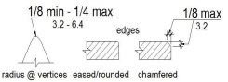
11B-703.7.2.7 Pedestrian Traffic-Control Buttons
Pole-supported pedestrian traffic-control buttons shall be identified with color coding consisting of a textured horizontal yellow band 2 inches (51 mm) in width encircling the pole, and a 1-inch-wide (25 mm) dark border band above and below this yellow band. Color coding shall be placed immediately above the control button. Control buttons shall be located no higher than 48 inches (1219 mm) above the ground surface adjacent to the pole.
11B-703.8 Variable Message Signs
11B-703.8.1 General
High resolution variable message sign (VMS) characters shall comply with Sections 11B-703.5 and 11B-703.8.12 through 11B-703.8.14. Low resolution variable message sign (VMS) characters shall comply with Section 11B-703.8.
11B-703.8.2 Case
Low resolution VMS characters shall be uppercase.
11B-703.8.3 Style
Low resolution VMS characters shall be conventional in form, shall be sans serif, and shall not be italic, oblique, script, highly decorative or of other unusual forms.
11B-703.8.4 Character Height
The uppercase letter "I" shall be used to determine the allowable height of all low resolution VMS characters of a font. Viewing distance shall be measured as the horizontal distance between the character and an obstruction preventing further approach towards the sign. The uppercase letter "I" of the font shall have a minimum height complying with Table 11B-703.8.4.
Exception: In assembly seating where the maximum viewing distance is 100 feet (30.5 m) or greater, the height of the uppercase "I" of low resolution VMS fonts shall be permitted to be 1 inch (25 mm) for every 30 feet (9144 mm) of viewing distance, provided the character height is 8 inches (203 mm) minimum. Viewing distance shall be measured as the horizontal distance between the character and where someone is expected to view the sign.
TABLE 11B-703.8.4—
LOW RESOLUTION VMS CHARACTER HEIGHT
HEIGHT ABOVE FLOOR TO  BASELINE OF CHARACTER | HORIZONTAL VIEWING  DISTANCE | MINIMUM  CHARACTER  HEIGHT
40 inches (1016 mm) to less than or  equal to 70 inches (1778 mm) | Less than 10 feet (3048 mm) | 2 inches (51 mm)
 | 10 feet  (3048 mm) and greater | 2 inches (51 mm), plus ¹/₅ inch (5.1 mm) per foot (305 mm)  of viewing distance above 10 feet (3048 mm)
Greater than  70 inches (1778 mm) to less than or  equal to 120 inches (3048 mm) | Less than 15 feet (4572 mm) | 3 inches (76 mm)
 | 15 feet  (4572 mm) and greater | 3 inches (76 mm), plus ¹/₅ inch (5.1 mm) per foot (305 mm)  of viewing distance above 15 feet (4572 mm)
Greater than 120 inches (3048 mm) | Less than 20 feet (6096 mm) | 4 inches (102 mm)
Greater than 120 inches (3048 mm) | 20 feet  (6096 mm) and greater | 4 inches (102 mm), plus ¹/₅ inch (5.1 mm) per foot (305 mm)  of viewing distance above 20 feet (6096 mm)
11B-703.8.5 Character Width
The uppercase letter "O" shall be used to determine the allowable width of all low resolution VMS characters of a font. Low resolution VMS characters shall comply with the pixel count for character width in Table 11B-703.8.5.
TABLE 11B-703.8.5—
PIXEL COUNT FOR LOW RESOLUTION VMS
CHARACTER HEIGHT | CHARACTER WIDTH RANGE | STROKE WIDTH RANGE | CHARACTER SPACING RANGE
7 | 5-6 | 1 | 2
8 | 6-7 | 1-2 | 2-3
9 | 6-8 | 1-2 | 2-3
10 | 7-9 | 2 | 2-4
11 | 8-10 | 2 | 2-4
12 | 8-11 | 2 | 3-4
13 | 9-12 | 2-3 | 3-5
14 | 10-13 | 2-3 | 3-5
15 | 11-14 | 2-3 | 3-5
FIGURE 11B-703.8.5—
LOW RESOLUTION VMS CHARACTERS
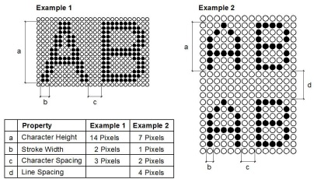
11B-703.8.6 Stroke Width
The uppercase letter "I" shall be used to determine the allowable stroke width of all low resolution VMS characters of a font. Low resolution VMS characters shall comply with the pixel count for stroke width in Table 11B-703.8.5.
11B-703.8.7 Character Spacing
Spacing shall be measured between the two closest points of adjacent low resolution VMS characters within a message, excluding word spaces. Low resolution VMS character spacing shall comply with the pixel count for character spacing in Table 11B-703.8.5.
11B-703.8.8 Line Spacing
Low resolution VMS characters shall comply with Section 11B-703.5.9.
11B-703.8.9 Height Above Floor
Low resolution VMS characters shall be 40 inches (1016 mm) minimum above the floor of the viewing position, measured to the baseline of the character. Heights of low resolution variable message sign characters shall comply with Table 11B-703.8.4, based on the size of the characters on the sign.
11B-703.8.10 Finish
The background of low resolution VMS characters shall have a nonglare finish.
11B-703.8.11 Contrast
Low resolution VMS characters shall be light characters on a dark background.
11B-703.8.12 Protective Covering
Where a protective layer is placed over VMS characters through which the VMS characters must be viewed, the protective covering shall have a nonglare finish.
11B-703.8.13 Brightness
The brightness of variable message signs in exterior locations shall automatically adjust in response to change in ambient light levels.
11B-703.8.14 Rate of Change
Where a VMS message can be displayed in its entirety on a single screen, it shall be displayed on a single screen and shall remain motionless on the screen for a minimum 3 seconds or 1 second minimum for every seven characters of the message including spaces, whichever is longer.
Section 11B-704 Telephones
11B-704.1 General
Public telephones shall comply with Section 11B-704.
11B-704.2 Wheelchair Accessible Telephones
Wheelchair accessible telephones shall comply with Section 11B-704.2.
11B-704.2.1 Clear Floor or Ground Space
A clear floor or ground space complying with Section 11B-305 shall be provided. The clear floor or ground space shall not be obstructed by bases, enclosures or seats.
11B-704.2.1.1 Parallel Approach
Where a parallel approach is provided, the distance from the edge of the telephone enclosure to the face of the telephone unit shall be 10 inches (254 mm) maximum.
FIGURE 11B-704.2.1.1—
PARALLEL APPROACH TO TELEPHONE
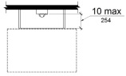
11B-704.2.1.2 Forward Approach
Where a forward approach is provided at a telephone within an enclosure, the counter may extend beyond the face of the telephone 20 inches (508 mm) into the required clear floor or ground space and the enclosure may extend beyond the face of the telephone 24 inches (610 mm). If an additional 6 inches (152 mm) in width of clear floor space is provided, creating a clear floor space of 36 inches by 48 inches (914 mm by 1219 mm), the enclosure may extend more than 24 inches (610 mm) beyond the face of the telephone.
FIGURE 11B-704.2.1.2—
FORWARD APPROACH TO TELEPHONE
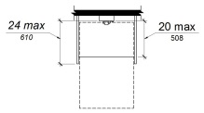
11B-704.2.2 Operable Parts
Operable parts shall comply with Section 11B-309. Telephones shall have push-button controls where such service is available.
11B-704.2.3 Telephone Directories
Telephone directories, where provided, shall be located in accordance with Section 11B-309.
11B-704.2.4 Cord Length
The cord from the telephone to the handset shall be 29 inches (737 mm) long minimum.
11B-704.3 Volume Control Telephones
Public telephones required to have volume controls shall be equipped with a receive volume control that provides a gain adjustable up to 20 dB minimum. For incremental volume control, provide at least one intermediate step of 12 dB of gain minimum. An automatic reset shall be provided. Volume control telephones shall be equipped with a receiver that generates a magnetic field in the area of the receiver cap. Public telephones with volume control shall be hearing aid compatible.
11B-704.4 TTYs
TTYs provided at a public pay telephone shall be permanently affixed within, or adjacent to, the telephone enclosure. Where an acoustic coupler is used, the telephone cord shall be sufficiently long to allow connection of the TTY and the telephone receiver.
11B-704.4.1 Height
When in use, the touch surface of TTY keypads shall be 34 inches (864 mm) minimum above the finish floor.
Exception: Where seats are provided, TTYs shall not be required to comply with Section 11B-704.4.1.
11B-704.5 TTY Shelf
Public pay telephones required to accommodate portable TTYs shall be equipped with a shelf and an electrical outlet within or adjacent to the telephone enclosure. The telephone handset shall be capable of being placed flush on the surface of the shelf. The shelf shall be capable of accommodating a TTY and shall have 6 inches (152 mm) minimum vertical clearance above the area where the TTY is to be placed.
Section 11B-705 Detectable Warnings and Detectable Directional Texture
11B-705.1 Detectable Warnings
FIGURE 11B-705.1—
SIZE AND SPACING OF TRUNCATED DOMES
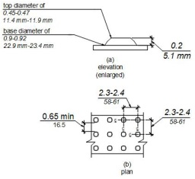
11B-705.1.1 General
Detectable warnings shall consist of a surface of truncated domes and shall comply with Section 11B-705.
11B-705.1.1.1 Dome Size
Truncated domes in a detectable warning surface shall have a base diameter of 0.9 inch (22.9 mm) minimum and 0.92 inch (23.4 mm) maximum, a top diameter of 0.45 inch (11.4 mm) minimum and 0.47 inch (11.9 mm) maximum, and a height of 0.2 inch (5.1 mm).
11B-705.1.1.2 Dome Spacing
Truncated domes in a detectable warning surface shall have a center-to-center spacing of 2.3 inches (58 mm) minimum and 2.4 inches (61 mm) maximum, and a base-to-base spacing of 0.65 inch (16.5 mm) minimum, measured between the most adjacent domes on a square grid.
Exception: Where installed in a radial pattern, truncated domes shall have a center-to-center spacing of 1.6 inches (41 mm) minimum to 2.4 inches (61 mm) maximum.
11B-705.1.1.3 Color and Contrast
Detectable warning surfaces shall comply with Section 11B-705.1.1.3.1. The material used to comply with this section shall be an integral part of the detectable warning surface.
Exceptions:
- Replacement of less than 20 percent of existing detectable warnings at a single contiguous location shall be permitted to be in-kind at existing curb ramps, islands or cut-through medians with detectable warnings in compliance with the code requirements in effect at the time of installation.
- Existing installed detectable warnings at curb ramps, islands or cut-through medians may comply with Section 11B-705.1.1.3.2 in lieu of Section 11B-705.1.1.3.1.
11B-705.1.1.3.1
Detectable warning surfaces shall be yellow and approximate 33538 of SAE AMS-STD-595A.
11B-705.1.1.3.2
Detectable warning surfaces shall provide a 70 percent minimum visual contrast with adjacent walking surfaces. Contrast in percent shall be determined by:
Contrast percent = [(B1-B2)/B1] × 100 where
B1 = light reflectance value (LRV) of the lighter area and
B2 = light reflectance value (LRV) of the darker area.
Exception: Where the detectable warning surface does not provide a 70 percent minimum contrast with adjacent walking surfaces, a 1-inch (25 mm) wide minimum visually contrasting surface shall separate the detectable warning from adjacent walking surfaces. The visually contrasting surface shall contrast with both the detectable warning and adjacent walking surfaces, either light-on-dark or dark-on-light.
11B-705.1.1.4 Resiliency
Detectable warning surfaces shall differ from adjoining surfaces in resiliency or sound-on-cane contact.
Exception: Detectable warning surfaces at curb ramps, islands or cut-through medians shall not be required to comply with Section 11B-705.1.1.4.
11B-705.1.2 Locations
Detectable warnings at the following locations shall comply with Section 11B-705.1.
11B-705.1.2.1 Platform Edges
Detectable warning surfaces at platform boarding edges shall be 24 inches (610 mm) wide and shall extend the full length of the public use areas of the platform.
11B-705.1.2.2 Curb Ramps
Detectable warnings at curb ramps shall comply with Section 11B-705.1.2.2.
11B-705.1.2.2.1 Perpendicular Curb Ramps
Detectable warnings at curb ramps shall extend 36 inches (914 mm) in the direction of travel. Detectable warnings shall extend the full width of the ramp run less 2 inches (51 mm) maximum on each side, excluding any flared sides. Detectable warnings shall be located so the edge nearest the curb is 6 inches (152 mm) minimum and 8 inches (203 mm) maximum from the demarcation line at the face of the curb between the curb and the gutter, street or highway.
11B-705.1.2.2.2 Parallel Curb Ramps
Diagram
Detectable warnings at parallel curb ramps shall be located so the edge nearest the curb is 6 inches (152 mm) minimum and 8 inches (203 mm) maximum from the demarcation line at the face of the curb between the curb and the gutter, street or highway. Detectable warnings shall extend the full width of the turning space at the demarcation between the street and the sidewalk less 2 inches (51 mm) maximum on each side.
FIGURE 11B-705.1.2.2.2—
PARALLEL CURB RAMPS
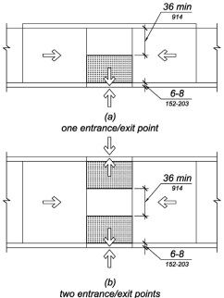
UpCodes Diagram (1)
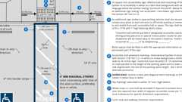Primary
Parking Stalls (CA 11B)
11B-705.1.2.2.2.1 One Entrance/Exit Point
Where the turning space has one entrance/exit point other than the sloped ramp segments, detectable warnings shall be 36 inches (914 mm) deep, as measured perpendicular to the curb, and the turning space shall provide a minimum 36 inches (914 mm) wide portion without detectable warnings to allow pedestrian travel in the direction of the sidewalk without travelling over the detectable warnings.
Exceptions:
- Where it is technically infeasible to provide a minimum 72 inches (1828 mm) wide turning space, as measured perpendicular to the curb, the depth of detectable warnings may be reduced to 24 inches (610 mm) minimum.
- Existing parallel curb ramps with detectable warnings in compliance with the code requirements in effect at the time of installation shall not be required to provide a minimum 36 inches (914 mm) wide portion of the turning space without detectable warnings.
11B-705.1.2.2.2.2 Two Entrance/Exit Points
Where the turning space has two entrance/exit points other than the sloped ramp segments, detectable warnings shall be 36 inches (914 mm) deep at both entrance/exit points, as measured perpendicular to the curb, and the turning space shall provide a minimum 36 inches (914 mm) wide portion without detectable warnings to allow pedestrian travel in the direction of the sidewalk without travelling over the detectable warnings.
Exceptions:
- Where it is technically infeasible to provide a minimum 108 inches (2743 mm) wide turning space, as measured perpendicular to the curb, the depth of detectable warnings may be reduced to 24 inches (610 mm) minimum.
- Existing parallel curb ramps with detectable warnings in compliance with the code requirements in effect at the time of installation shall not be required to provide a minimum 36 inches (914 mm) wide portion of the turning space without detectable warnings.
11B-705.1.2.3 Islands or Cut-Through Medians
Detectable warnings at pedestrian islands or cut-through medians shall be 36 inches (914 mm) minimum in depth extending the full width of the pedestrian path or cut-through less 2 inches (51 mm) maximum on each side, placed at the edges of the pedestrian island or cut-through median, and shall be separated by 24 inches (610 mm) minimum of walking surface without detectable warnings.
Exception: Detectable warnings shall be 24 inches (610 mm) minimum in depth at pedestrian islands or cut-through medians that are less than 96 inches (2438 mm) in length in the direction of pedestrian travel.
11B-705.1.2.4 Bus Stops
When detectable warnings are provided at bus stop boarding and alighting areas, the detectable warnings shall extend the full width of the boarding/alighting area and shall be 36 inches (914 mm) minimum in depth.
11B-705.1.2.5 Blended Transitions
Diagram
Detectable warnings at blended transitions shall be 36 inches (914 mm) in depth and extend the entirety of the transition separating the walk or sidewalk from the vehicular way.
UpCodes Diagram (1)
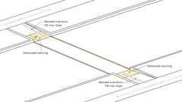Primary
Blended Transitions
11B-705.1.2.6 Reflecting Pools
When detectable warnings are provided at reflecting pools, it shall be 24 inches (610 mm) minimum and 36 inches (914 mm) maximum in width.
11B-705.1.2.7 Track Crossings
Detectable warnings at track crossings shall be 36 inches (914 mm) in the direction of pedestrian travel and extend the full width of the circulation path.
11B-705.2 Detectable Directional Texture
Detectable directional texture at transit boarding platforms shall comply with Figure 11B-705.2 and shall be 0.1 inch (2.5 mm) in height that tapers off to 0.04 inch (1.0 mm), with bars raised 0.2 inch (5.1 mm) from the surface. The raised bars shall be 1.3 inches (33 mm) wide and 3 inches (76 mm) from center-to-center of each bar. This surface shall differ from adjoining walking surfaces in resiliency or sound-on-cane contact. The color shall be yellow and approximate FS 33538 of Federal Standard 595C. This surface will be placed directly behind the yellow detectable warning texture specified in Section 11B- 705.1.2.1, aligning with all doors of the transit vehicles where passengers will embark. The width of the directional texture shall be equal to the width of the transit vehicle's door opening. The depth of the texture shall not be less than 36 inches (914 mm).
FIGURE 11B-705.2—
DETECTABLE DIRECTIONAL TEXTURE
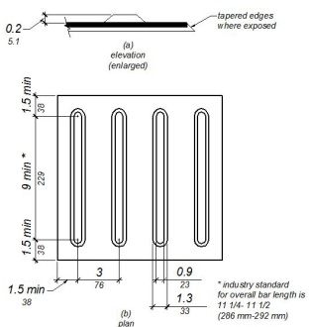
11B-705.3 Product Approval
Only approved DSA-AC detectable warning products and directional surfaces shall be installed as provided in the California Code of Regulations (CCR), Title 24, Part 1, Chapter 5, Articles 2, 3 and 4. Refer to CCR Title 24, Part 12, Chapter 11B, Section 12-11B.205 for building and facility access specifications for product approval for detectable warning products and directional surfaces.
Section 11B-706 Assistive Listening Systems
11B-706.1 General
Assistive listening systems required in assembly areas, conference and meeting rooms shall comply with Section 11B-706.
11B-706.2 Receiver Jacks
Receivers required for use with an assistive listening system shall include a ¹/₈ inch (3.2 mm) standard mono jack.
11B-706.3 Receiver Hearing-Aid Compatibility
Receivers required to be hearing-aid compatible shall interface with telecoils in hearing aids through the provision of neckloops.
11B-706.4 Sound Pressure Level
Assistive listening systems shall be capable of providing a sound pressure level of 110 dB minimum and 118 dB maximum with a dynamic range on the volume control of 50 dB.
11B-706.5 Signal-to-Noise Ratio
The signal-to-noise ratio for internally generated noise in assistive listening systems shall be 18 dB minimum.
11B-706.6 Peak Clipping Level
Peak clipping shall not exceed 18 dB of clipping relative to the peaks of speech.
Section 11B-707 Automatic Teller Machines, Fare Machines and Point-of-Sale Devices
11B-707.1 General
Automatic teller machines, fare machines and point-of-sale devices shall comply with Section 11B-707.
11B-707.2 Clear Floor or Ground Space
A clear floor or ground space complying with Section 11B-305 shall be provided.
Exception: Clear floor or ground space shall not be required at drive-up only automatic teller machines and fare machines.
11B-707.3 Operable Parts
Operable parts shall comply with Section 11B-309. Unless a clear or correct key is provided, each operable part shall be able to be differentiated by sound or touch, without activation.
Exceptions:
- Drive-up only automatic teller machines and fare machines shall not be required to comply with Sections 11B-309.2 and 11B-309.3.
- Where automatic teller machines and fare machines do not require compliance with Section 11B-707.2, compliance with Sections 11B-309.2 and 11B-309.3 shall not be required.
- Where point-of-sale devices do not require compliance with Section 11B-707.2, compliance with Sections 11B-309.2 and 11B-309.3 shall not be required.
11B-707.4 Privacy
Automatic teller machines shall provide the opportunity for the same degree of privacy of input and output available to all individuals.
11B-707.5 Speech Output
Machines shall be speech enabled. Operating instructions and orientation, visible transaction prompts, user input verification, error messages, and all displayed information for full use shall be accessible to and independently usable by individuals with vision impairments. Speech shall be delivered through a mechanism that is readily available to all users, including but not limited to, an industry standard connector or a telephone handset. Speech shall be recorded or digitized human, or synthesized.
Exceptions:
- Audible tones shall be permitted instead of speech for visible output that is not displayed for security purposes, including but not limited to, asterisks representing personal identification numbers.
- Advertisements and other similar information shall not be required to be audible unless they convey information that can be used in the transaction being conducted.
- Where speech synthesis cannot be supported, dynamic alphabetic output shall not be required to be audible.
11B-707.5.1 User Control
Speech shall be capable of being repeated or interrupted. Volume control shall be provided for the speech function.
Exception: Speech output for any single function shall be permitted to be automatically interrupted when a transaction is selected.
11B-707.5.2 Receipts
Where receipts are provided, speech output devices shall provide audible balance inquiry information, error messages and all other information on the printed receipt necessary to complete or verify the transaction.
Exceptions:
- Machine location, date and time of transaction, customer account number, and the machine identifier shall not be required to be audible.
- Information on printed receipts that duplicates information available on-screen shall not be required to be presented in the form of an audible receipt.
- Printed copies of bank statements and checks shall not be required to be audible.
11B-707.6 Input
Input devices shall comply with Section 11B-707.6.
11B-707.6.1 Input Controls
At least one tactilely discernible input control shall be provided for each function. Where provided, key surfaces not on active areas of display screens, shall be raised above surrounding surfaces. Where membrane keys are the only method of input, each shall be tactilely discernible from surrounding surfaces and adjacent keys.
11B-707.6.2 Numeric Keys
Numeric keys shall be arranged in a 12-key ascending or descending telephone keypad layout. The number five key shall be tactilely distinct from the other keys.
FIGURE 11B-707.6.2—
NUMERIC KEY LAYOUT
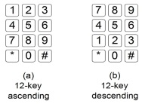
11B-707.6.3 Function Keys
Function keys shall comply with Section 11B-707.6.3.
11B-707.6.3.1 Contrast
Function keys shall contrast visually from background surfaces. Characters and symbols on key surfaces shall contrast visually from key surfaces. Visual contrast shall be either light-on-dark or dark-on-light.
Exception: Tactile symbols required by Section 11B-707.6.3.2 shall not be required to comply with Section 11B-707.6.3.1.
11B-707.6.3.2 Tactile Symbols
Function key surfaces shall have tactile symbols as follows: Enter or Proceed key: raised circle; Clear or Correct key: raised left arrow; Cancel key: raised letter ex; Add Value key: raised plus sign; Decrease Value key: raised minus sign.
11B-707.7 Display Screen
The display screen shall comply with Section 11B-707.7.
Exception: Drive-up only automatic teller machines and fare machines shall not be required to comply with Section 11B-707.7.1.
11B-707.7.1 Visibility
The display screen shall be visible from a point located 40 inches (1016 mm) above the center of the clear floor space in front of the machine.
11B-707.7.1.1 Vertically Mounted Display Screen
Where display screens are mounted vertically or tipped away from the viewer less than 30 degrees, the center line of the display screen and other display devices shall be no more than 52 inches (1321 mm) above the floor or ground surface.
11B-707.7.1.2 Angle-Mounted Display Screen
Where display screens are mounted tipped away from the viewer 30 degrees to less than 60 degrees from vertical, the center line of the display screen and other display devices shall be no more than 44 inches (1118 mm) above the floor or ground surface.
11B-707.7.1.3 Horizontally Mounted Display Screen
Where display screens are mounted tipped away from the viewer 60 degrees to 90 degrees (horizontal) from vertical, the center line of the display screen and other display devices shall be no more than 34 inches (864 mm) above the floor or ground surface.
11B-707.7.2 Characters
Characters displayed on the screen shall be in a sans serif font. Characters shall be ³/₁₆ inch (4.8 mm) high minimum based on the uppercase letter "I". Characters shall contrast with their background with either light characters on a dark background or dark characters on a light background.
11B-707.8 Braille Instructions
Braille instructions for initiating the speech mode shall be provided. Braille shall comply with Section 11B-703.3.
11B-707.9 Point-of-Sale Devices
Point-of-sale devices shall comply with Section 11B-707.9.
11B-707.9.1 General
Point-of-sale systems that include a video touch screen or any other non-tactile keypad shall be equipped with either of the following:
11B-707.9.1.1 Tactilely Discernible Numerical Keypad
A tactilely discernible numerical keypad similar to a telephone keypad containing a raised dot with a dot base diameter between 1.5 mm and 1.6 mm and a height between 0.6 mm and 0.9 mm on the number 5 key that enables a visually impaired person to enter his or her own personal identification number or any other personal information necessary to process the transaction in a manner that provides the opportunity for the same degree of privacy input and output available to all individuals.
11B-707.9.1.2 Other Technology
Other technology, such as a radio frequency identification device, fingerprint biometrics or some other mechanism that enables a visually impaired person to access the video touch screen device with his or her personal identifier and to process his or her transaction in a manner that provides the opportunity for the same degree of privacy input and output available to all individuals. Where a video screen overlay is provided it shall be equipped with a tactilely discernible numerical keypad complying with Section 11B-707.9.1.1.
Section 11B-708 Two-Way Communication Systems
11B-708.1 General
Two-way communication systems shall comply with Section 11B-708.
11B-708.2 Audible and Visual Indicators
The system shall provide both audible and visual signals.
11B-708.3 Handsets
Handset cords, if provided, shall be 29 inches (737 mm) long minimum.
11B-708.4 Residential Dwelling Unit Communication Systems
Communications systems between a residential dwelling unit and a site, building or floor entrance shall comply with Section 11B-708.4.
11B-708.4.1 Common Use or Public Use System Interface
The common use or public use system interface shall include the capability of supporting voice and TTY communication with the residential dwelling unit interface.
11B-708.4.2 Residential Dwelling Unit Interface
The residential dwelling unit system interface shall include a telephone jack capable of supporting voice and TTY communication with the common use or public use system interface.
Division 8 Special Rooms, Spaces and Elements
Section 11B-801 General
11B-801.1 Scope
The provisions of Division 8 shall apply where required by Division 2 or where referenced by a requirement in this chapter .
Section 11B-802 Wheelchair Spaces, Companion Seats and Designated Aisle Seats and Semi-Ambulant Seats
11B-802.1 Wheelchair Spaces
Diagram
Wheelchair spaces shall comply with Section 11B-802.1.
UpCodes Diagrams (4)
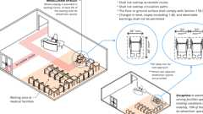
Waiting Areas in Medical Facilities (11B)
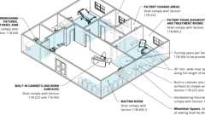
Professional Offices of Health Care Providers
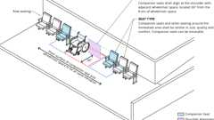
Companion Seats
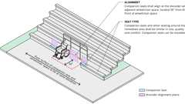
Companion Seats - Bleachers
11B-802.1.1 Floor or Ground Surface
The floor or ground surface of wheelchair spaces shall comply with Section 11B-302. Changes in level, slopes exceeding 1:48, and detectable warnings shall not be permitted.
Exception: Reserved.
11B-802.1.2 Width
A single wheelchair space shall be 36 inches (914 mm) wide minimum. Where two adjacent wheelchair spaces are provided, each wheelchair space shall be 33 inches (838 mm) wide minimum.
FIGURE 11B-802.1.2—
WIDTH OF WHEELCHAIR SPACES
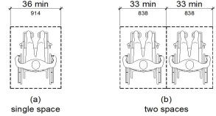
11B-802.1.3 Depth
Where a wheelchair space can be entered from the front or rear, the wheelchair space shall be 48 inches (1219 mm) deep minimum. Where a wheelchair space can be entered only from the side, the wheelchair space shall be 60 inches (1524 mm) deep minimum.
FIGURE 11B-802.1.3—
DEPTH OF WHEELCHAIR SPACES
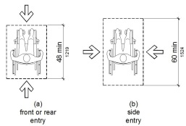
11B-802.1.4 Approach
Wheelchair spaces shall adjoin accessible routes. Accessible routes shall not overlap wheelchair spaces.
11B-802.1.5 Overlap
Wheelchair spaces shall not overlap circulation paths.
11B-802.2 Lines of Sight
Lines of sight to the screen, performance area or playing field for spectators in wheelchair spaces shall comply with Section 11B-802.2.
11B-802.2.1 Lines of Sight Over Seated Spectators
Where spectators are expected to remain seated during events, spectators in wheelchair spaces shall be afforded lines of sight complying with Section 11B-802.2.1.
11B-802.2.1.1 Lines of Sight Over Heads
Where spectators are provided lines of sight over the heads of spectators seated in the first row in front of their seats, spectators seated in wheelchair spaces shall be afforded lines of sight over the heads of seated spectators in the first row in front of wheelchair spaces.
FIGURE 11B-802.2.1.1—
LINES OF SIGHT OVER THE HEADS OF SEATED SPECTATORS
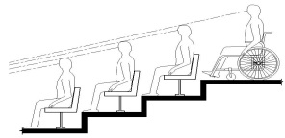
11B-802.2.1.2 Lines of Sight Between Heads
Where spectators are provided lines of sight over the shoulders and between the heads of spectators seated in the first row in front of their seats, spectators seated in wheelchair spaces shall be afforded lines of sight over the shoulders and between the heads of seated spectators in the first row in front of wheelchair spaces.
FIGURE 11B-802.2.1.2—
LINES OF SIGHT BETWEEN THE HEADS OF SEATED SPECTATORS
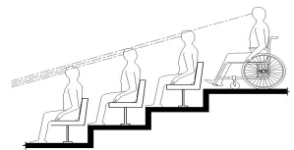
11B-802.2.2 Lines of Sight Over Standing Spectators
Where spectators are expected to stand during events, spectators in wheelchair spaces shall be afforded lines of sight complying with Section 11B-802.2.2.
11B-802.2.2.1 Lines of Sight Over Heads
Where standing spectators are provided lines of sight over the heads of spectators standing in the first row in front of their seats, spectators seated in wheelchair spaces shall be afforded lines of sight over the heads of standing spectators in the first row in front of wheelchair spaces.
FIGURE 11B-802.2.2.1—
LINES OF SIGHT OVER THE HEADS OF STANDING SPECTATORS
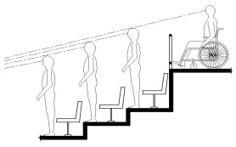
11B-802.2.2.2 Lines of Sight Between Heads
Where standing spectators are provided lines of sight over the shoulders and between the heads of spectators standing in the first row in front of their seats, spectators seated in wheelchair spaces shall be afforded lines of sight over the shoulders and between the heads of standing spectators in the first row in front of wheelchair spaces.
FIGURE 11B-802.2.2.2—
LINES OF SIGHT BETWEEN THE HEADS OF STANDING SPECTATORS
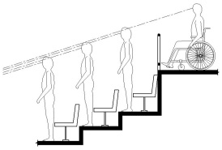
11B-802.3 Companion Seats
Diagram
Companion seats shall comply with Section 11B-802.3.
UpCodes Diagrams (2)
Primary
Companion Seats - Bleachers
Primary
Companion Seats
11B-802.3.1 Alignment
In row seating, companion seats shall be located to provide shoulder alignment with adjacent wheelchair spaces. The shoulder alignment point of the wheelchair space shall be measured 36 inches (914 mm) from the front of the wheelchair space. The floor surface of the companion seat shall be at the same elevation as the floor surface of the wheelchair space.
11B-802.3.2 Type
Companion seats shall be equivalent in size, quality, comfort and amenities to the seating in the immediate area. Companion seats shall be permitted to be movable.
11B-802.4 Designated Aisle Seats
Designated aisle seats shall comply with Section 11B-802.4.
11B-802.4.1 Armrests
Where armrests are provided on the seating in the immediate area, folding or retractable armrests shall be provided on the aisle side of the seat.
11B-802.4.2 Identification
Each designated aisle seat shall be identified by a sign or marker with the International Symbol of Accessibility complying with Section 11B-703.7.2.1. Signs complying with Section 11B-703.5, notifying patrons of the availability of such seats shall be posted at the ticket office.
11B-802.5 Semi-Ambulant Seats
Semi-ambulant seats shall provide at least 24 inches (610 mm) clear leg space between the front of the seat to the nearest obstruction or to the back of the seat immediately in front.
Section 11B-803 Dressing, Fitting and Locker Rooms
Diagram
UpCodes Diagrams (4)
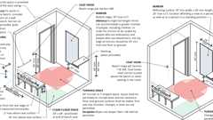Primary
Fitting Rooms: ADA vs. CA 11B
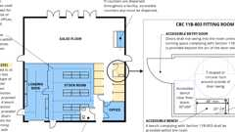
Retail (CA 11B)
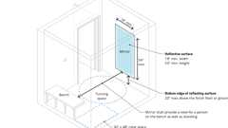
Mirrors in Locker, Dressing, or Fitting Rooms (CA 11B)
Benches (CA 11B)
Building products (3)
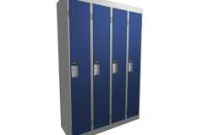
Corridor (Emperor) Lockers
Hadrian Solutions ULC

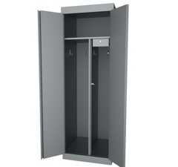
Specialty Lockers
Hadrian Solutions ULC

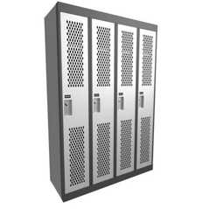
​​Athletic (Gladiator) Lockers
Hadrian Solutions ULC

11B-803.1 General
Dressing, fitting and locker rooms shall comply with Section 11B-803.
11B-803.2 Turning Space
Turning space complying with Section 11B-304 shall be provided within the room.
11B-803.3 Door Swing
Diagram
Doors shall not swing into the room unless a turning space complying with Section 11B-304.3 is provided beyond the arc of the door swing.
UpCodes Diagram (1)
Fitting Rooms: ADA vs. CA 11B
11B-803.4 Benches
Diagram
A bench complying with Section 11B-903 shall be provided within the room.
UpCodes Diagrams (2)
Benches (CA 11B)
Fitting Rooms: ADA vs. CA 11B
11B-803.5 Coat Hooks and Shelves
Diagram
Coat hooks provided within the room shall be located within one of the reach ranges specified in Section 11B-308. Shelves shall be 40 inches (1016 mm) minimum and 48 inches (1219 mm) maximum above the finish floor or ground. Coat hooks shall not be located above the bench or other seating in the room.
UpCodes Diagrams (2)
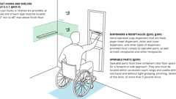
Mounting Heights: Bathroom Accessories
Fitting Rooms: ADA vs. CA 11B
11B-803.6 Mirrors
Diagram
Mirrors shall be installed with the bottom edge of the reflecting surface 20 inches (508 mm) maximum above the finish floor or ground. Mirrors shall be full length with a reflective surface 18 inches (457 mm) wide minimum by 54 inches (1372 mm) high minimum and shall be mounted in a position affording a view to a person on the bench as well as to a person in a standing position.
UpCodes Diagrams (2)
Primary
Mirrors in Locker, Dressing, or Fitting Rooms (CA 11B)
Fitting Rooms: ADA vs. CA 11B
Section 11B-804 Kitchens, Kitchenettes and Wet Bars
Diagram
UpCodes Diagram (1)
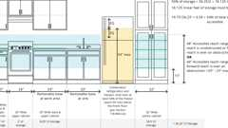
Accessible Shelving (CA 11B)
Building products (2)
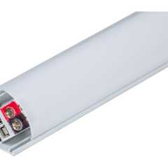
600 Lumens/Ft. Angled Linear Fixture, Tunable-White, 2700K–5000K - LT-P3
Task Lighting and Power

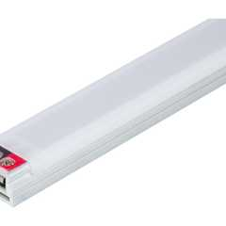
Flat Profile Linear Fixtures - Single-White - LS-P7
Task Lighting and Power

11B-804.1 General
Kitchens, kitchenettes and wet bars shall comply with Section 11B-804.
11B-804.2 Clearance
Where a pass through kitchen is provided, clearances shall comply with Section 11B-804.2.1. Where a U-shaped kitchen is provided, clearances shall comply with Section 11B-804.2.2.
Exception: Spaces that do not provide a cooktop or conventional range shall not be required to comply with Section 11B-804.2.
11B-804.2.1 Pass Through Kitchen
In pass through kitchens where counters, appliances or cabinets are on two opposing sides, or where counters, appliances or cabinets are opposite a parallel wall, clearance between all opposing base cabinets, countertops, appliances or walls within kitchen work areas shall be 40 inches (1016 mm) minimum. Pass through kitchens shall have two entries.
FIGURE 11B-804.2.1—
PASS THROUGH KITCHENS
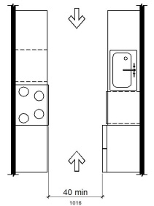
11B-804.2.2 U-Shaped
In U-shaped kitchens enclosed on three contiguous sides, clearance between all opposing base cabinets, countertops, appliances or walls within kitchen work areas shall be 60 inches (1524 mm) minimum.
FIGURE 11B-804.2.2—
U-SHAPED KITCHENS
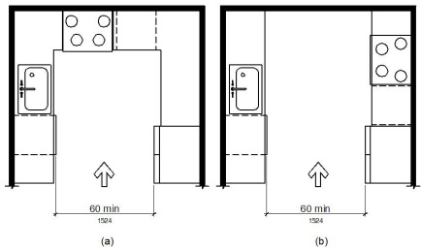
11B-804.2.3 Turning Space
In kitchens within multi-bedroom housing units and on floors containing accessible sleeping rooms with adaptable features in undergraduate student housing, turning spaces complying with Section 11B-304 shall be provided.
11B-804.3 Kitchen Work Surface
In residential dwelling units required to comply with Section 11B-809, at least one 30 inches (762 mm) wide minimum section of counter shall provide a kitchen work surface that complies with Section 11B-804.3. In kitchens within multi-bedroom housing units and on floors containing accessible sleeping rooms with adaptable features in undergraduate student housing, at least one 30 inches (762 mm) wide minimum section of counter shall provide a kitchen work surface that complies with Section 11B-804.3.
11B-804.3.1 Clear Floor or Ground Space
A clear floor space complying with Section 11B-305 positioned for a forward approach shall be provided. The clear floor or ground space shall be centered on the kitchen work surface and shall provide knee and toe clearance complying with Section 11B-306.
Exception: Cabinetry shall be permitted under the kitchen work surface provided that all of the following conditions are met:
- the cabinetry can be removed without removal or replacement of the kitchen work surface;
- the finish floor extends under the cabinetry; and
- the walls behind and surrounding the cabinetry are finished.
11B-804.3.2 Height
The kitchen work surface shall be 34 inches (864 mm) maximum above the finish floor or ground.
Exception: A counter that is adjustable to provide a kitchen work surface at variable heights, 29 inches (737 mm) minimum and 36 inches (914 mm) maximum, shall be permitted.
11B-804.3.3 Exposed Surfaces
There shall be no sharp or abrasive surfaces under the work surface counters.
11B-804.4 Sinks
Sinks shall comply with Section 11B-606.
Building products (2)
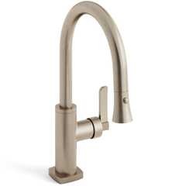
H-Line Low Gooseneck Kitchen Faucet With Pull Down Spray
Watermark Designs

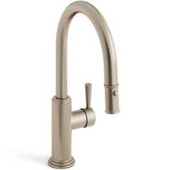
Stratford 1 Hole Gooseneck Kitchen Faucet With Pull Down Spray
Watermark Designs

11B-804.5 Storage
Diagram
At least 50 percent of shelf space in storage facilities shall comply with Section 11B-811.
UpCodes Diagram (1)
Primary
Accessible Shelving (CA 11B)
11B-804.6 Appliances
Diagram
Where provided, kitchen appliances shall comply with Section 11B-804.6.
UpCodes Diagram (1)
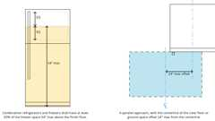
Accessible Refrigerators
11B-804.6.1 Clear Floor or Ground Space
Diagram
A clear floor or ground space complying with Section 11B-305 shall be provided at each kitchen appliance. Clear floor or ground spaces shall be permitted to overlap.
UpCodes Diagram (1)
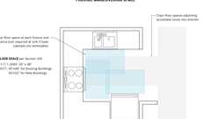
Kitchens: Clearance Overlaps (FHA)
11B-804.6.2 Operable Parts
All appliance controls shall comply with Section 11B-309.
Exceptions:
- Appliance doors and door latching devices shall not be required to comply with Section 11B-309.4.
- Bottom-hinged appliance doors, when in the open position, shall not be required to comply with Section 11B-309.3.
11B-804.6.3 Dishwasher
Clear floor or ground space shall be positioned adjacent to the dishwasher door. The dishwasher door, in the open position, shall not obstruct the clear floor or ground space for the dishwasher or the sink.
11B-804.6.4 Range or Cooktop
Where a forward approach is provided, the clear floor or ground space shall provide knee and toe clearance complying with Section 11B-306. Where knee and toe space is provided, the underside of the range or cooktop shall be insulated or otherwise configured to prevent burns, abrasions or electrical shock. The location of controls shall not require reaching across burners.
11B-804.6.5 Oven
Ovens shall comply with Section 11B-804.6.5.
11B-804.6.5.1 Side-Hinged Door Ovens
Side-hinged door ovens shall have the work surface required by Section 11B-804.3 positioned adjacent to the latch side of the oven door.
11B-804.6.5.2 Bottom-Hinged Door Ovens
Bottom-hinged door ovens shall have the work surface required by Section 11B-804.3 positioned adjacent to one side of the door.
11B-804.6.5.3 Controls
Ovens shall have controls on front panels.
11B-804.6.6 Refrigerator/Freezer
Diagram
Combination refrigerators and freezers shall have at least 50 percent of the freezer space 54 inches (1372 mm) maximum above the finish floor or ground. The clear floor or ground space shall be positioned for a parallel approach to the space dedicated to a refrigerator/freezer with the centerline of the clear floor or ground space offset 24 inches (610 mm) maximum from the centerline of the dedicated space.
UpCodes Diagram (1)
Accessible Refrigerators
Section 11B-805 Medical Care and Long-Term Care Facilities
Diagram
UpCodes Diagrams (3)
Waiting Areas in Medical Facilities (11B)
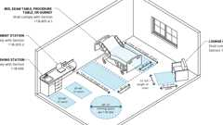
Exam, Diagnostic and Treatment Room
Professional Offices of Health Care Providers
11B-805.1 General
Medical care facilities and long-term care facilities shall comply with Section 11B-805. All common use spaces and public use spaces in medical care facilities and long-term care facilities shall comply with this chapter.
11B-805.2 Patient Bedrooms and Resident Sleeping Rooms
Diagram
Patient bedrooms and resident sleeping rooms required to provide mobility features shall comply with Section 11B-805.2.
UpCodes Diagram (1)
Professional Offices of Health Care Providers
11B-805.2.1 Hand Washing Fixtures
Hand washing fixtures shall comply with Section 11B-606.
11B-805.2.2 Beds
A 36 inch (914 mm) minimum wide clear space shall be provided along the full length of each side of the beds.
11B-805.2.3 Turning Space
Turning space complying with Section 11B-304 shall be provided within the room.
11B-805.2.4 Toilet and Bathing Rooms
Toilet and bathing rooms that are provided as part of patient bedrooms and resident sleeping rooms complying with Section 11B-223.2 or 11B-223.3 shall comply with Section 11B-603. Where provided, one water closet, one lavatory and one bathtub or shower shall comply with the applicable requirements of Sections 11B-603 through 11B-610.
11B-805.3 Waiting Rooms
Diagram
Waiting rooms shall comply with Section 11B-805.3.
UpCodes Diagrams (2)
Primary
Waiting Areas in Medical Facilities (11B)
Professional Offices of Health Care Providers
11B-805.3.1 Wheelchair Spaces
Where seating is provided in waiting rooms, at least 5 percent of the seating shall be wheelchair spaces complying with Section 11B-802.1.
Exception: In waiting rooms serving facilities specializing in treating conditions that affect mobility, 10 percent of the seating shall be wheelchair spaces complying with Section 11B-802.1.
11B-805.4 Examination, Diagnostic and Treatment Rooms
Diagram
Examination, diagnostic and treatment rooms shall comply with Section 11B-805.4.
UpCodes Diagram (1)
Primary
Exam, Diagnostic and Treatment Room
11B-805.4.1 Beds, Exam Tables, Procedure Tables, Gurneys and Lounge Chairs
A 36-inch (914 mm) minimum wide clear space shall be provided along the full length of each side of beds, exam tables, procedure tables, gurneys and lounge chairs.
Exception: General exam rooms in non-emergency settings may provide clear space on only one side of beds, gurneys and exam tables.
11B-805.4.2 Equipment
Clear space complying with Section 11B-305.2 shall be provided as required for specific equipment.
11B-805.4.3 Turning Space
Turning space complying with Section 11B-304 shall be provided within the room.
11B-805.5 Patient Change Areas
Areas where patients change or are prepared for a procedure shall comply with Section 11B-222.
11B-805.6 Hand Washing Fixtures, Lavatories and Sinks
All hand washing fixtures, lavatories and sinks shall comply with Section 11B-606.
Exception: Scrub sinks, as defined in California Plumbing Code Section 221.0, shall not be required to comply with Section 11B-606.
11B-805.7 Built-In Cabinets and Work Surfaces
Built-in cabinets, counters and work surfaces shall be accessible, including: patient wardrobes, nurse stations, administrative centers, reception desks, medicine preparation areas, laboratory work stations, equipment consoles, clean and soiled utility cabinets and storage areas; and shall comply with Sections 11B-225 and 11B-902.
Exceptions:
- Built-in wardrobes in patient bedrooms and resident sleeping rooms not required to be accessible are not required to comply with the provisions of this chapter.
- Clinical laboratory work stations provided in a laboratory area that are in addition to the minimum number required to be accessible (5 percent of the work stations provided, but no fewer than one), are not required to comply with the provisions of Section 11B-902.

